SS350HD Bull-Dog Model

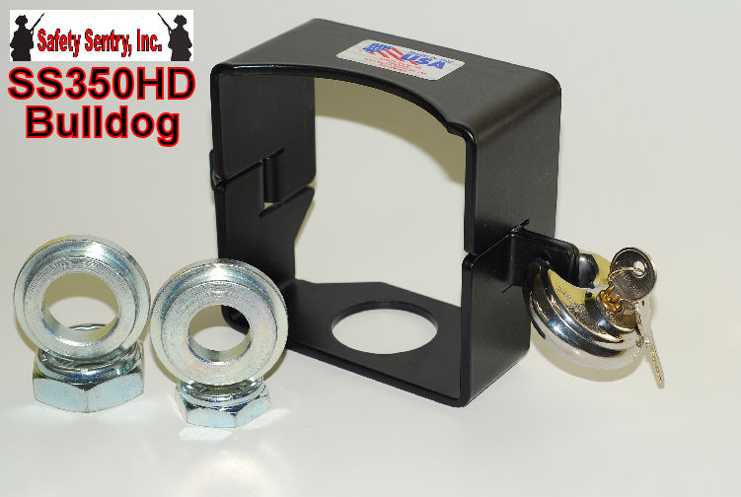

SS350HD Bulldog Trailer Hitch Safety and Security System is designed for your heavy duty 2" and 2 5/16" Commercial Applications from 4500 lbs to 15,000 lbs. applications.

The SS350BD Model Safety System includes Heavy Duty Steel Housing, Stainless, 2 step washers for either size trailer ball shanks 1" or 1 1/4", 2 Nylon lock nuts 1" and 1 1/4" and Steel Cut Resistant/Freon Resistant keyed disc lock for ease of installation; a complete Safety & Security System for your trailer. Make sure your trailer ball is securely tightened to manufactures specs of 100 ft lbs.

MAKE SURE THAT COUPLER SIZE AND BALL SIZES ARE CORRECT FOR THIS APPLICATION!

The Importance of using Cut Resistant and Freon Resistant circular Stainless Steel Lock
Includes: Maximum Security Cut/ Defense Technology
*STAINLESS STEEL*
*ACIER INOXYDABLE*
*ACERO INOXIDABLE*
- ALL WARRANTIES ARE VOID IF NOT USED ON APPLICATIONS OF SAFETY SENTRY DUE TO THE ENGINEERED SAFETY FEATURES OF SYSTEM
- THIS LOCK IS PROVIDED FOR THE INTEGRITY OF SAFETY SENTRY APPLICATIONS

