SS350HD Model

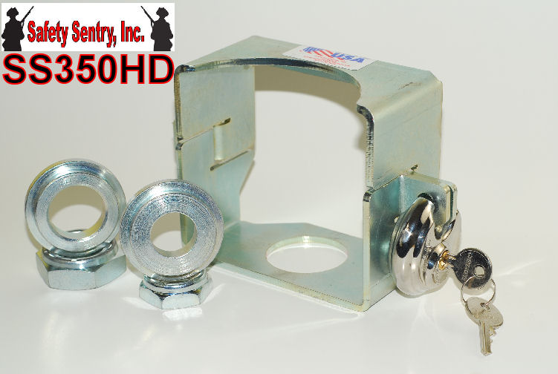

SPECIAL APPLICATION Safety Sentry Model SS350HD is a "Complete Towing Accessory" for one of the most popular RV and Commercial Hitch Couplers. Designed for the Atwood 2" MODEL# 88555 8000 lb. or the 2 5/16" MODEL# 64-4102 10,000 lb. for Commercial and RV Applications.
SS350HD Safety Sentry Towing Accessory
The Safety Sentry SS350HD MODEL comes complete with everything necessary to Safely and Securely complete your towing experience.
The SS350HD is designed for your Commercial & Recreational Vehicle 8000-10000 lb. applications.

Included with the SS350HD Safety and Security System includes the Safety Sentry Housing, 2 Step Washers and Nylon Lock Nuts for Shank Sizes 1" and 1 1/4" for either Trailer Ball size 2" or 2 5/16" to insure installation and provides a complete Safety & Security System for your trailer. Make sure your trailer ball is securely tightened to manufactures specs of 100 ft lbs.

MAKE SURE COUPLER SIZE AND BALL SIZES ARE CORRECT BEFORE INSTALLATION!
The Importance of using Cut Resistant and Freon Resistant circular Stainless Steel Lock
Includes: Maximum Security Cut/ Defense Technology
*STAINLESS STEEL*
*ACIER INOXYDABLE*
*ACERO INOXIDABLE*
- ALL WARRANTIES ARE VOID IF NOT USED ON APPLICATIONS OF SAFETY SENTRY DUE TO THE ENGINEERED SAFETY FEATURES OF SYSTEM
- THIS LOCK IS PROVIDED FOR THE INTEGRITY OF SAFETY SENTRY APPLICATIONS

