SS300 Model

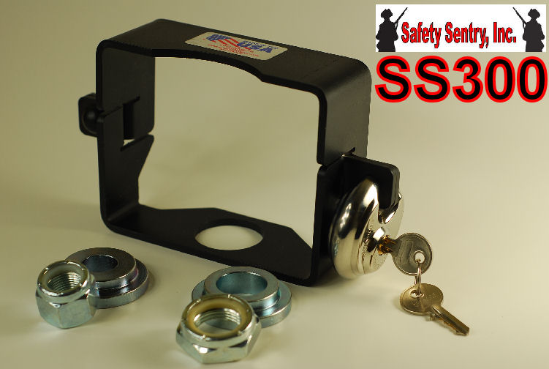
SS300 Safety Sentry Towing Accessory
The Safety Sentry SS300 MODEL comes complete with everything necessary to Safely and Securely complete your towing experience.
The SS300 is designed for your 2500 lbs to 4000 lbs 2" hitch couplers.

Included with the Safety Sentry SS300 MODEL; the Safety Sentry housing with 2 step washers for 2” Trailer Balls using either 1" or 3/4" Trailer Ball shank. Includes Cut Resistant and Freon Resistant circular Stainless Steel Lock and 2 Lock Nuts for either 1" or 3/4" Trailer Ball shanks; a complete Safety & Security System for your trailer.

MAKE SURE YOUR COUPLER AND BALL SIZES ARE CORRECT UPON INSTALLATION!
The Importance of using Cut Resistant and Freon Resistant circular Stainless Steel Lock
Includes: Maximum Security Cut/ Defense Technology
*STAINLESS STEEL*
*ACIER INOXYDABLE*
*ACERO INOXIDABLE*
- ALL WARRANTIES ARE VOID IF NOT USED ON APPLICATIONS OF SAFETY SENTRY DUE TO THE ENGINEERED SAFETY FEATURES OF SYSTEM
- THIS LOCK IS PROVIDED FOR THE INTEGRITY OF SAFETY SENTRY APPLICATIONS

