SS200 Model

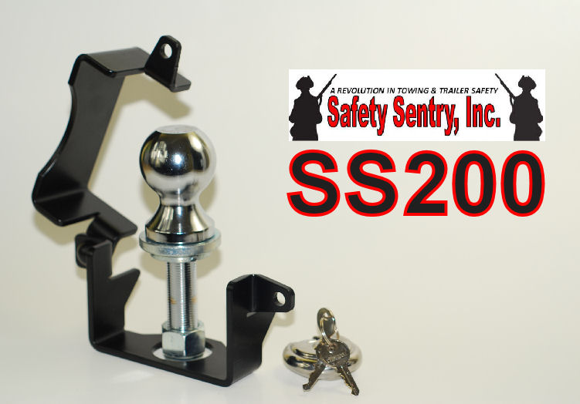
SS200 Safety Sentry Towing Accessory
The Safety Sentry SS200 MODEL comes complete with everything necessary to Safely and Securely complete your towing experience.
The SS200 is designed for your small trailers equipped with 1 7/8" Trailer Ball coupler.

Included with the Safety Sentry SS200 MODEL; Safety Sentry housing and the Safety Sentry trailer ball standoff components for use with 1 7/8” trailer ball. Includes Cut Resistant and Freon Resistant circular Stainless Steel Lock and 2 Lock Nuts for either 1" or 3/4" Trailer Ball shanks; providing a complete Safety & Security System for your trailer.

MAKE SURE YOUR COUPLER AND BALL SIZES ARE CORRECT UPON INSTALLATION!
The Importance of using Cut Resistant and Freon Resistant circular Stainless Steel Lock
Includes: Maximum Security Cut/ Defense Technology
*STAINLESS STEEL*
*ACIER INOXYDABLE*
*ACERO INOXIDABLE*
- ALL WARRANTIES ARE VOID IF NOT USED ON APPLICATIONS OF SAFETY SENTRY DUE TO THE ENGINEERED SAFETY FEATURES OF SYSTEM
- THIS LOCK IS PROVIDED FOR THE INTEGRITY OF SAFETY SENTRY APPLICATIONS

