DOT/DPS Trailer Accident Statistics
Welcome to the Safety Sentry Department of Public Safety / The Department of Transportation information center. Through the help of many agencies we have put together some information regarding trailer accidents and cost so you can be a little more informed of Statistics and what Safety Sentry Inc. is trying to prevent.
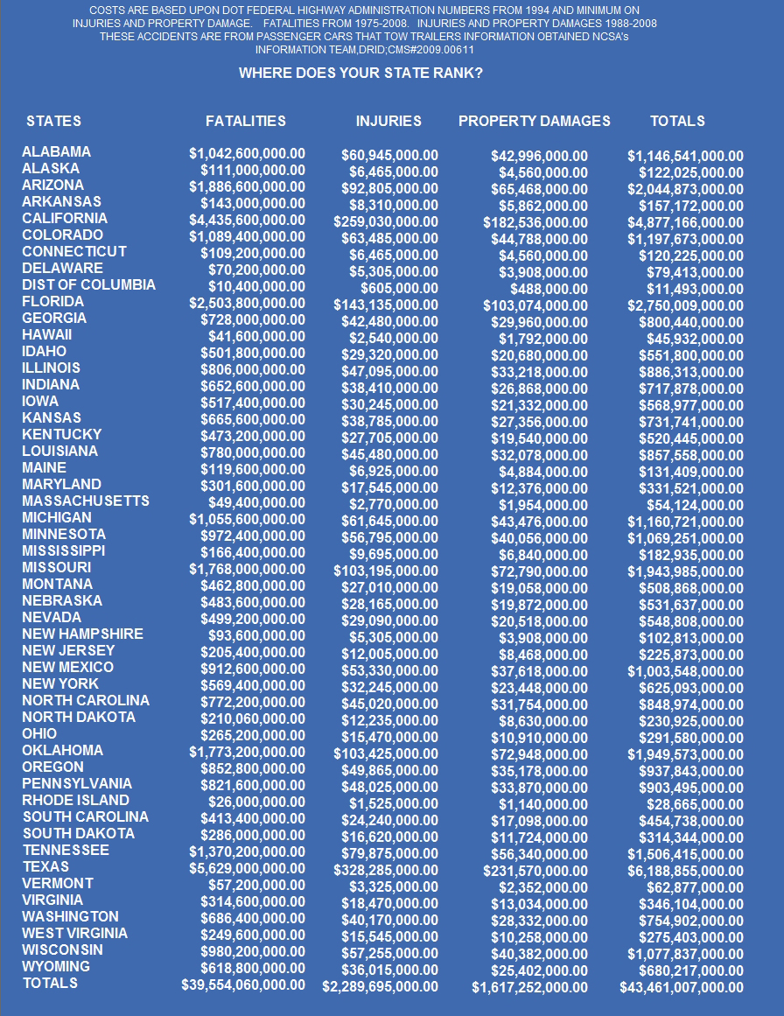
Each State can reduce these numbers.
One of the largest contributors to these accidents is disengagements while towing.

